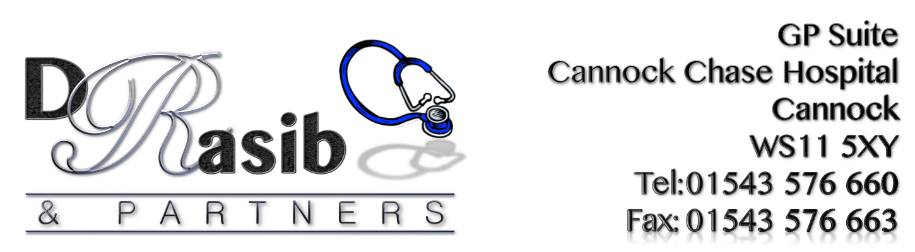
RESULTS FOR PATIENT SURVEY 2016

84% of patients felt happy with the explanation to their problems/queries when visiting the GP – No action required

86% of patients stated that they had a preference in booking appointments over the phone. The practice feels that this needs to change in order to help reduce the telephone congestion that it is currently facing. There are other methods of booking appointments other than the phone and this needs to be shared amongst the patients more. If we can try and aim to reduce the congestion then this could possibly allow the telephones to be freed up to allow for more complicated queries to be dealt with. This item is to be included on the Action Plan.

The results from last years survey showed that 48% of patients had difficulties getting through on the telephone. This year this has increased to 61%, there is still obviously an issue with the phones. Having resourced prices from external telephony services, it was apparent that this was deemed to be more expensive than our current internal systems within the hospital. Also there are technical issues in trying to implement a new telephone system - This item is to be included on the Action Plan.

83% of patients stated that they were happy with the Practice appointment system and the new booking in machine, this has improved by 1% from last year, some patients do feel that booking in reception creates a more personal touch which is understandable but we need to continue to encourage the use of the booking in machine whenever and wherever possible – No action required

47% of patients stated that they were not aware of how to make a complaint, which is a 6% increase from last year. Further leaflets shall be produced for patients to have access to. The procedure shall also be advertised further within the waiting area. Details shall also be added to the Practice leaflet and the practice website will be reviewed to try and make the procedure more obvious to patients. This item is to be included on the Action Plan.

92% of patients surveyed were happy with the service provided by the receptionists, this shows a 10% increase from last year – No action required.

85% of patients surveyed stated that they find it easy to discuss any queries with the reception staff.

84% of patients surveyed said that they were happy with the GPs at the practice, this shows a 14% increase from last years results – No action required.

60% of patients stated that they couldn’t suggest anything to help improve the surgery, however 24% of patients surveyed made suggestions and the theme was ‘more appointments’ and ‘getting through on the phone’. Both these areas are recognized by the practice and we would like to ask the PPG members and patients to help us with ideas on how this can be done using the current resources (IT and Staff). This item is to be included on the Action Plan.

61% of patients surveyed told us that they are not aware of the patient Buddy Scheme so the aim would be to advertise this more, PPG members to be involved in this process – This item is to be included on the Action Plan.

80% of patients said that they would not consider becoming a patient buddy in order to support other patients. The Practice will continue to raise awareness about this throughout the year to see whether interest can be increased - This item is to be included on the Action Plan.

GENERAL COMMENTS RECEIVED:

GOOD POINTS:
- Surgery really friendly and very understanding
- Quite happy
- Dr Rasib brilliant
- Very happy with Dr Rasib
- Very happy especially Laura
- Receptionists are great

BAD POINTS:
- Could do with a drinks machine
- More and closer parking especially parent and child
- More pre-bookable appointments please
- Difficulty getting through to surgery first thing due to volume of calls
- Phone lines
- Having a female doctor available 5 days
- Very difficult to get through at 8am
- Being able to get through on phone
- Appointment availability needs improvement
- More female doctors
- Pre-bookable appointments
- Make easier to book appointment over the phone and Pre-bookable would be an advantage

